Task One: Stormwater Drainage Infrastructure Survey and Data Entry

In Accra, June-July 2024, we carried out a stormwater drainage survey to identify exposed stormwater drainage points along street segments that were clogged with solid water (i.e., plastics and rubbish) and stagnated for the purpose of reducing the burden of poor environmental sanitation and risk of mosquito-borne infestation.

Following information has been captured in annotated images:

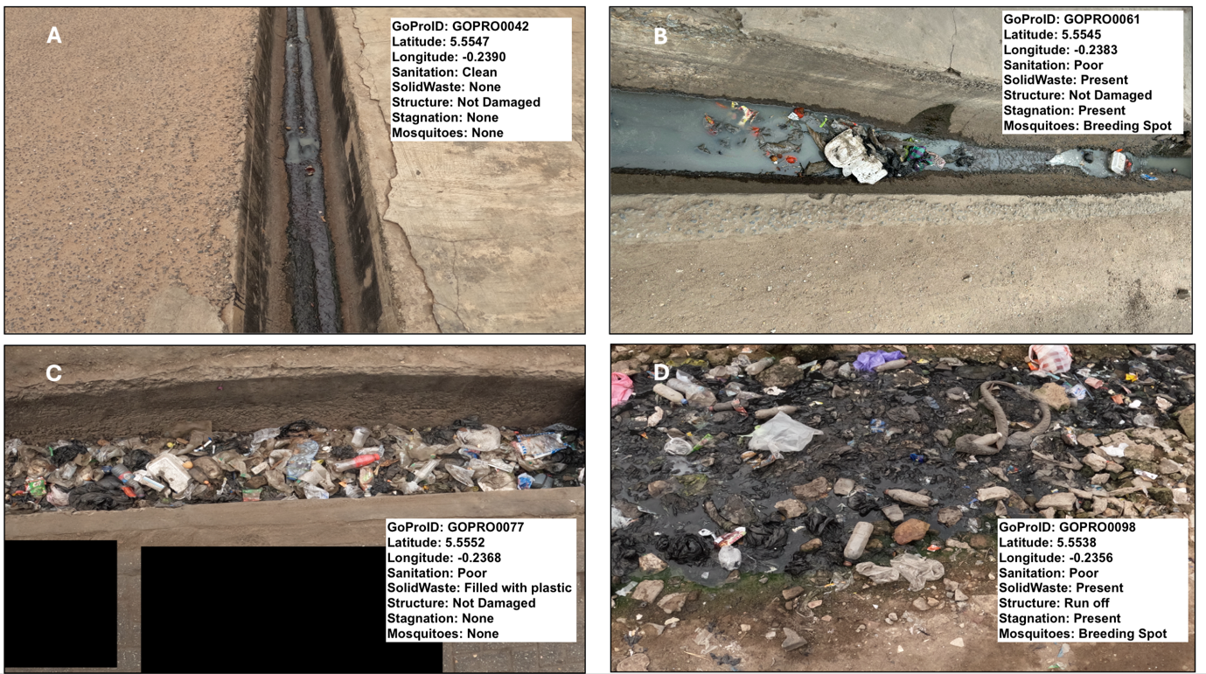

Use the information inside the images’ text box to construct a data frame in RStudio.

- Use the c( ) function with assignment operator (<-) to create the following vector objects with the names:
- GoProID: it contains the image ID numbers
- Latitude: it contains the y-coordinate of surveyed location
- Longitude: it contains the x-coordinate of surveyed location
- Sanitation: it contains information about the sanitation state of drain
- SolidWaste: it describes presence or absence of solid waste materials in drain
- Structure: it describes whether the structure of the drain was damaged (or not) or it being a “run off” drain
- Stagnation: refers to flow obstruction in drain resulting in it be stagnated
- Mosquitoes: refers to evidence of mosquito breeding in drain due to condition

- Use the data.frame( ) with the assignment operator (<-) to create the data frame object `drainage_data`.
- Use the following row conditions i.e., drains classified as having Poor sanitary state AND it is a Breeding Spot for mosquitoes to perform a filter on the `drainage_data` object. At the same time, limit the filtered data to the following columns: `GoProID`, `Latitude`, `Longitude`, `Sanitation` and `Mosquitoes`
- Use the write.csv( ) to save your new filtered dataset.
- Use the str() function to provide a description of the full dataset.
- Provide a screenshot of the data frame – this could be any dataset – the one created from Question 1 or Question 3.

Brief Notes:

For this task, the students are expected to know the following:

- Assignment operator (<-) to assigning values, or data frames to objects
- How to use the combine function c( ) for listing observations into a vector object
- How to build a data frame
- How to filter a data frame based on conditions
- Describe the structure of the data frame generated from Question 1
- Screenshot of the output

Solution - codes

# 1. R syntax for creating the vector objects

GoProID <- c("GOPRO0042", "GOPRO0061", "GOPRO0077", "GOPRO0098")
Latitude <- c(5.5547, 5.5545, 5.5552, 5.5538)
Longitude <- c(-0.2390, -0.2383, -0.2368, 0.2356)
Sanitation <- c("Clean", "Poor", "Poor", "Poor")
SolidWaste <- c("None", "Present", "Filled with Plastic", "Present")
Structure <- c("Not Damaged", "Not Damaged", "Not Damaged", "Run off")
Stagnation <- c("None", "Present", "None", "Present")
Mosquitoes <- c("None", "Breeding Spot", "None", "Breeding Spot")

# 2. R syntax for creating the data frame
drainage_data <- data.frame(GoProID, Latitude, Longitude, Sanitation, SolidWaste, Structure, Stagnation, Mosquitoes)

# 3. R syntax for subsetting on rows and columns
drainage_data_filter <- drainage_data[drainage_data$Sanitation == "Poor" & drainage_data$Mosquitoes == "Breeding Spot", c(1, 2, 3, 4, 8)]

# 4. R syntax for saving your new dataset
write.csv(drainage_data_filter, file = "Filtered_Drainage_Data.csv", row.names = FALSE)

# 5. Report data structure
str(drainage_data)

Solution - screenshot of full data frame
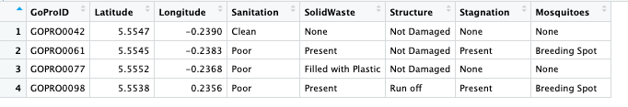

Solution - screenshot of filtered data frame based on conditions in Question 3
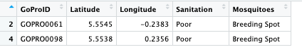

Solution – Interpretation, or description of full data frame’s structure created in Question 1 using str() code

This data frame contains 4 rows and 8 columns. The GoProID column a variable contain unique identifiers which are string characters. The Longitude and Latitude columns are variables contain information about location of these drainages – these are numeric columns. The remaining 5 columns (i.e., Sanitation, SolidWaste, Structure, Stagnation and Mosquitoes are examples of categorical variables which all contain string characters.

Note: They are expected to do a simple description of this data frame’s structure – mentioning what the columns in terms of type and if they are string characters or numeric values.

